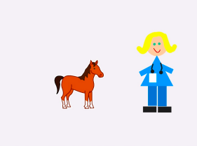
Dr. Dr. Pony Joke

Activity Structure – 45min
Overview
In this joke, children can start to understand how jokes are coded and messages are sent and received, and quickly create something fun to listen and watch straight away, while having a good laugh!
We can then start to talk about how to make the joke harder or easier: making the characters smaller or larger, moving faster or slower, making the pony gallop or move slower or faster.
# | Activity | Timing
1. | Introduce project | 5 mins
2. | New project & add backdrop | 5 mins
3. | Add characters | 10 mins
4. | Code & test | 10 mins
5. | Add speed changes | 5 mins
6. | Debug & Demo | 5 mins
Project Plan
Step by Step
- See if children can figure out what code blocks are needed for sending a joke and the reply. Act it out!
- In a new project, add a plain-colour background, or background of your choice. Delete the cat character.
- Add a pony character from selection and shrink horse by dragging shrink block down and tapping once or twice. Drag pony to left of page.
- Add Doctor character by drawing freehand or using circles and squares. Drag Doctor to right of page.
- Code the Horse using blocks shown on code sheet. Record Sound clip: “Dr. Dr. I Feel Like a Pony!”
- Code the Doctor using blocks shown on code sheet. Record Sound clip: “Don’t worry, you’re just a little horse!”
- Name & Save Project. Set to Full screen, touch the green flag and Test.
- Extension: Could the pony gallop off? How?

- f
Code Sheets
Basic project
The Pony
The Doctor

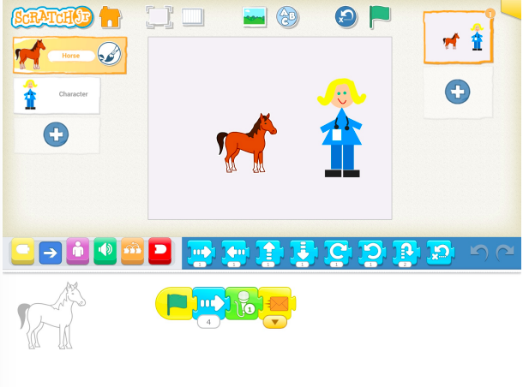
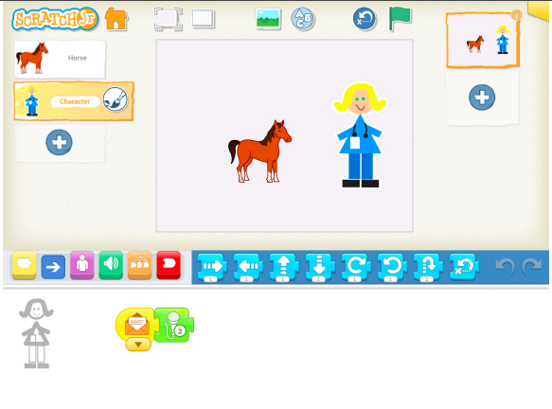

Simplification:
Younger children can simply make the horse move forward and leave out the extra movement and sound clips.
Extension activities:
Children can add more movement to the Horse and the Doctor.
Children can be challenged to make the characters laugh at the end using another sound clip.
How could we reset the characters at the end to repeat the joke?

Project Materials
Learning outcomes

